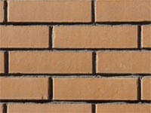

**Мои ошибки воспитания** ________________________________________________________________________________________________________________________________________________________________________________________________________________________

**Мои достоинства** ________________________________________________________________________________________________________________________________________________________________________________________________________________________

Мне не нравилось, когда мои родители _____________ _____________________________________________________________________________________________________________________________

Когда я был ребенком _________________________ _____________________________________________________________________________________________________________________________